**How to Force Complete(Task) in EFMS**

**Step 1:** Run below query to check the status of the task in EFMS Database:

SQL>> select ord.usrp_order_number, wf.name, wf.status, wf.job_id, wf.task_id from ms_order ord, ms_sub_order sub, ms_job j, wf_task wf, wf_job job where wf.name in ('GIOM Tier Error') and ord.usrp_order_number in ('183262142') and ord.ms_order_id = sub.ms_order_id and ms_sub_order_id = j.entity_id and wf.job_id = hextoraw (j.wf_job_id) and wf.job_id = job.job_id and j.entity_type=5;

**Task Status**

-- 0 = Waiting

-- 1 = READY

-- 2 = ACQUIRED

-- 3 = Complete

-- 4 = Skipped

-- 5 = In-Progress

**Step 2a:** In below screen shot you will see task “GIOM Tier Error” status shows **1** is in Ready State, GO TO STEP 3:



**Step 2b:** If the status of the task is ‘4’ that is skipped then inform user that “**Task is skipped in EFMS please check again**”:



**Step 2c:** If the task is in waiting status i.e. ‘0’

Display user that “**Task is not in ready status, kindly work on ready task to progress workflow”**.

**Step 2d:** If the task is in completed status i.e. ‘3’

Display user that “**Task is already completed in EFMS.”**

**Step 3:** **Force complete** GIOM Tier Error task in EFMS.

Steps to Force Complete the task:

* Login to asprd246 machine as prodsupp

/usr/localcw/bin/sudo su - m67007

/usr/localcw/bin/sudo su – prodsupp

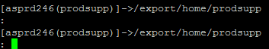

* Go to directory – Complete

cd complete

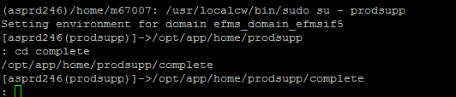

* Execute below script to Force complete.

fc.run

* HIT ENTER

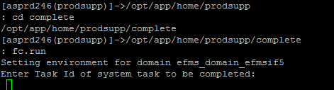

* It will ask for Task ID which user want to complete, fetch it from Step 1 and bypass here.
* You will get notification on same screen indicating task has been completed.